**Experiment 2**

**Aim:** (a) Generate a unit impulse, unit step and signum function using input functions ‘zeros’ and ‘ones’. Plot a discrete time graph for each.

(b) Generate a square wave (continuous and discrete) of frequency 50Hz and sampling frequency 1000Hz having a duty cycle of 25%, 50% and 75%.

(c) Generate a sinusoidal signal when user inputs the frequency amplitude and its phase.

**Software Used :** MATLAB 2016a

**Code :**

**(a)**

clc

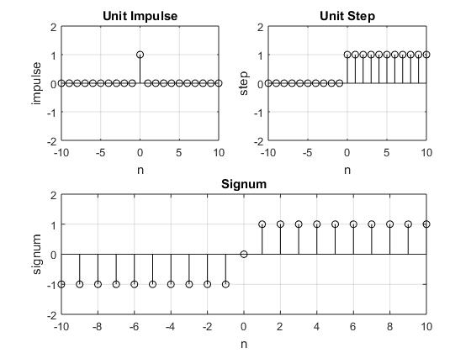

clear all

close all

n=-10:1:10

subplot(2,2,1)

z=[zeros(1,10),1,zeros(1,10)]

stem(n,z,'k')

axis([-10 10 -2 2])

title('Unit Impulse')

xlabel('n')

ylabel('impulse')

grid on

subplot(2,2,2)

s=[zeros(1,10),ones(1,11)]

stem(n,s,'k')

axis([-10 10 -2 2])

title('Unit Step')

xlabel('n')

ylabel('step')

grid on

subplot(2,2,[3,4])

sig=[-(ones(1,10)),0,ones(1,10)]

stem(n,sig,'k')

axis([-10 10 -2 2])

title('Signum')

xlabel('n')

ylabel('signum')

grid on

**(b)**

clc

clear all

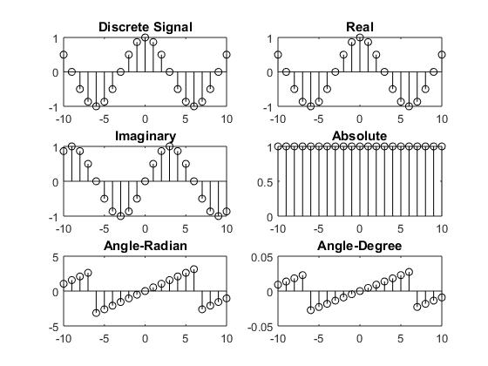

close all

n=0:.001:.1

subplot(3,2,2)

s=square(2*pi*50*n,25)

stem(n,s,'k')

title('Discrete with 25% duty cycle')

axis([0 .1 -2 2])

grid on

subplot(3,2,4)

s=square(2*pi*50*n,50)

stem(n,s,'k')

axis([0 .1 -2 2])

title('Discrete with 50% duty cycle')

grid on

subplot(3,2,6)

s=square(2*pi*50*n,75)

stem(n,s,'k')

title('Discrete with 75% duty cycle')

grid on

axis([0 .1 -2 2])

subplot(3,2,1)

s=square(2*pi*50*n,25)

plot(n,s,'k')

title('Continuous with 25% duty cycle')

grid on

axis([0 .1 -2 2])

subplot(3,2,3)

s=square(2*pi*50*n,50)

plot(n,s,'k')

title('Continuous with 50% duty cycle')

grid on

axis([0 .1 -2 2])

subplot(3,2,5)

s=square(2*pi*50*n,75)

plot(n,s,'k')

title('Continuous with 75% duty cycle')

grid on

axis([0 .1 -2 2])

**(c)**

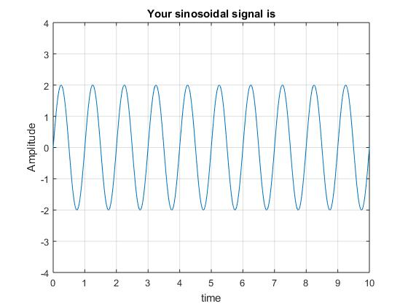

clc

clear all

close all

t=0:.01:10

prompt='Enter the amplitude';

A=input(prompt);

prompt='Enter the frequency';

f=input(prompt);

prompt='Enter the phase';

ph=input(prompt);

x=A*sin(2*pi*f*t+ph);

plot(t,x)

axis([0 10 -A-2 A+2])

title('Your sinosoidal signal is')

xlabel('time')

ylabel('Amplitude')

grid on